1. A Man and His Children
- God’s first recorded command to man in the Bible is, “Be a Dad”!

“God said to the man and the woman, ‘Be fruitful and multiply, and fill the earth, and subdue it.... Genesis 1:28

- Children are given by God to enrich a man’s life in a multitude of ways.

“Behold, children are a gift of the Lord, the fruit of the womb is a reward. Psalm 127:3

“For unflagging interest and enjoyment, a household of children certainly makes all other forms of success and achievement lose their importance by comparison.¹
Teddy Roosevelt

- Children give a dad a way to make some of his most significant and enduring contributions to bettering this world.

“Children are the living messages we send to a time we will not see.² Author Neil Postman

- The challenge every dad faces is how to raise up and launch well- adjusted, difference-making children into the next generation. As we learned in Session 4, this requires more than being a “good dad”. This requires being a “smart dad”.

2. What Your Children Would Say They Most Need From You As Dad:
- “Dad, I need you and Mom to be there for me in my early years.”
- Studies have shown that a strong, nurturing environment in the opening years of a child’s life along with lots of face to face interaction with mom and dad, is essential to healthy brain and personality development.³

“One of the things I have learned in my psychiatric training is that approximately eight-five percent of a person’s ultimate personality is formed by the time he or she is six years old. Those first six years are obviously the most crucial.⁴ Psychiatrist Paul Meier

- Studies have also shown that young children with limited physical and emotional attention from busy or absent parents will struggle later on.⁵
- Dads, far more than moms, wound their children for a lifetime by being out of touch with them in the early years. Dad’s absence is particularly damaging to sons.

“No one outgrows his feelings of childhood. For better or for worse, the child lives on in the adult.⁶ Child Psychiatrist, Hugh Misseldine

- “Dad, I need your discipline and instruction to be balanced with love.”

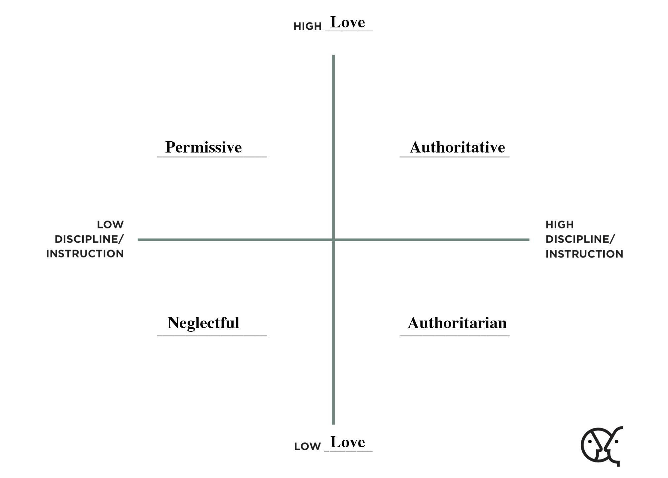

CHILDREN RAISED IN AUTHORITATIVE HOMES WERE MORE LIKELY TO:

- Adopt the values of the family.
- Respond to authority figures.
- Possess a high sense of personal well being.

- “Dad, I need you to know my personality and honor it.”
- There is no “one-size-fits-all” parenting style. The smart dad will adjust his parenting efforts to fit each of his children’s unique personalities.
- The sooner a dad knows his children’s unique personalities, the better. This insight will help you as a dad better connect and interact with each of your children and avoid unnecessary hurts.
- There are many resources available to help you discover your child’s personality. (A book that’s easy for you and your family to use to determine personality differences is Personality Plus for Parents by Florence Littauer.)⁷

- “Dad, I need you to discover my “bent” and actively support it.”
- Don’t push your children to be what you want; help them become what God has gifted them to be. Their “bent” is their natural abilities and passions.

“ Train up a child according to his bent, and even when he is old he will not depart from it.
Proverbs 22:6

- Do you know your child’s natural abilities and passions? In a child’s teenage years, the smart dad will use aptitude testing to find out. (A great resource for discovering your child’s bent rather than guessing at it can be found at aimstesting.org)⁸
- Your excitement and support as a dad for your child’s natural abilities and passions is a huge factor in his or her healthy development.

- “Dad, I need you to know too much is too much.”
- Too much control over your child’s life crushes the spirit and incites rebellion.
- Too much money in your child’s life will spoil them and steal their will to succeed.
- Too high expectations for your child wounds and embitters them.

“ Fathers, do not exasperate your children, so that they will not lose heart. Colossians 3:21

- “Dad, I need you to show me what to believe by living it.”

“ Faith, if it has no works, is dead, being by itself. James 2:17

- Research shows over and over again that children are more inclined to embrace the faith of their parents if they witnessed dad or mom applying their beliefs to real life situations.
- Bottom line: You will leave in your children what you have lived out in your home.

- “Dad, I need you to bless me.”
- Every child needs dad to speak “The Blessing” directly into his or her life. This “blessing” was introduced to you in Session 4 as a “must do” for the smart dad. It consists of three heart felt statements:
- “I love you”
- “I’m proud of you.”
- “You’re really good at…”
- This blessing by dad can never be given enough to his child, either publicly or privately.
- Even Jesus needed this blessing as a Son from His Father.

“ Behold, a voice out of the cloud said, ‘This is My beloved Son, with whom I am well-pleased; listen to Him!’ Matthew 17:5

- “Dad, I need you to adjust your leadership style to me as I grow up.”
- From ages 1-13, you need to be your child’s coach.
- From ages 13-18, you need to change and be your child’s cheerleader.
- From ages 18 on, you need to change again and be your child’s consultant.

- “Dad, I need to make some great memories with you.”
- There is often a direct correlation between the memories we keep from childhood and the lives we live as adults.
- Every child can be strengthened for life by special moments with dad that then live
forever in heart.
- The smart dad works at creating personal, memory-making experiences with his
children every year.

- “Dad, I need you to talk to me about God and share His Word with me.”
- Children have a natural curiosity about God. Our job as smart dads is to build on that curiosity, not squelch it.

“ Jesus called to them saying, ‘Permit the children to come to Me, and do not hinder them, for the kingdom of God belongs to such as these.’’
Luke 18:16

- One of the best things you can do as a dad is to tell your children about your relationship with God and what His Word is teaching you.

3. Final Thoughts
- Children are God’s gifts to us.
- We feel that “gifting” most in two “wow” moments:
- The day they are born.
- The day they stand before us as mature, honorable adults.

- Children are our best, long-term opportunity to better God’s world.

“ Like arrows in the hand of a warrior, so are the children of one’s youth. Psalm 127:4

- They are the “arrows” of change we shoot to shape the future

- Children are ours to love and guide into becoming healthy, productive, God-glorifying adults. Such a responsibility will humble the smart dad. He knows how inadequate he is for such a task. He knows he needs God to succeed, and that reality will drive him to constantly call on God for His wisdom and help.

A FATHER’S PRAYER

“ Build me a son, O Lord, who will be strong enough to know when he is weak, brave enough to face himself when he is afraid, one who will be proud and unbending in honest defeat, and humble and gentle in victory.

Build me a son, O Lord, whose wishes will not take the place of deeds; a son who will know Thee - and that to know himself is the foundation stone of knowledge.

Lead him I pray, not in the path of ease and comfort, but under the stress and spur of difficulties and challenge. Here let him learn and stand up in the storm, here let him learn compassion for those who fail.

Build me a son whose heart will be clear, whose goals will be high, a son who will master himself before he seeks to master others... one who will reach into the future yet never forget the past.

And after all these things, add, I pray, enough of a sense of humor, so that he may always be serious, yet never take himself too seriously. Give him humility so that he may always remember the simplicity of true greatness, the open mind of true wisdom, and the meekness of true strength.

Then I, his father, will dare to whisper, ‘I have not lived my life in vain.⁹
General Douglas McArthur

Your Table Discussion Questions
- Share where you marked your parenting style on the love/instruction scale we looked at earlier in this session. Where would your wife put you? Where would you put your dad’s parenting style of you?

- Which one of the ten needs of children did you feel most drawn to? Why?

- Which one of these ten needs would you say you were most challenged by? Explain.

Your “BetterMan” Question
Before our next session, take a moment this week to reflect on your notes, and then answer the following question: What possible action step could I take from this session that could make me a better man? Write your answer down in the space below.

Your “BetterMan” Plan
After you have answered this final “BetterMan” question, take some time and look back over how you answered this question in Sessions 2-9 After reviewing your answers, ask yourself this question: From the possible action steps I have considered during BetterMan, which three would I be willing to commit myself to as a “BetterMan Plan” for upgrading my manhood in the months ahead. Write down these three action steps below, and be ready to share them with your table next week.

IMPORTANT
Don’t forget that next week we have our special “Week 11” graduation. We will celebrate together the end of our BetterMan journey, share our 3 selected BetterMan action steps for going forward, and hear about how to connect with the BetterMan Organization for more manhood adventures. You don’t want to miss this!

