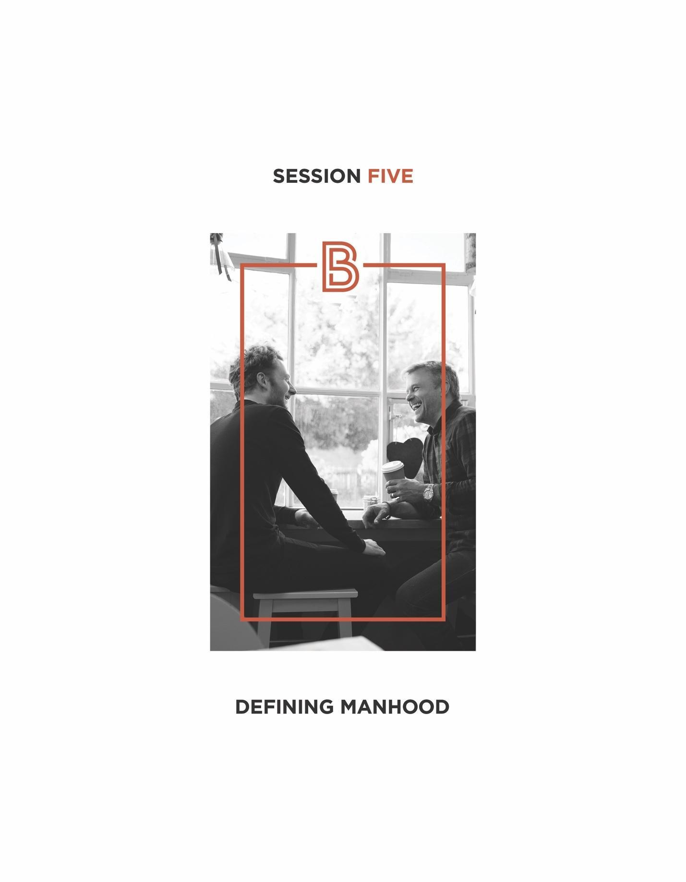

- It’s Time to Define!
- Every man needs a clear definition of manhood to guide his life.

It’s hard to become what you can’t define.

- Our options:
- We can make up a definition for ourselves.
- We can look to culture to define it for us.
- We can look to enduring wisdom for a definition.

“ Stand by the roads, and look and ask for the ancient paths, where the good way is; and walk in it, and find rest for your souls. Jeremiah 6:16

- So what is history’s greatest source of enduring wisdom? It’s the Bible.
- No book has transformed more lives for good than the Bible has.
- It is history’s all-time best seller.
- Every week, 31% of the world’s population looks to the Bible for guidance and help.
- The Bible laid the moral, social, and legal foundations for all of Western Civilization.
- Every culture influenced by the truths of the Bible has flourished.

- The Bible and Manhood
- The Genesis story introduces us to a timeless manhood.
- Immediately after his creation, God calls Adam to step up to four, specific, life-giving responsibilities that if embraced, would make him truly manly.
- As sons of Adam, these manhood responsibilities have now been passed to us to guide us in our journey to a better manhood.

- The Four Life-Giving Responsibilities of Real Manhood
- A real man courageously follows God’s word.

Unlike the animal world, man was created with a special need for personal coaching to succeed.

“ The Lord God commanded the man, saying, “From any tree of the garden you may eat freely; but from the tree of the knowledge of good and evil you shall not eat, for in the day that you eat from it you shall surely die. Genesis 2:16-17

A man begins to experience the real adventure of life-giving manhood when he courageously follows God’s Word.

“ Be strong and courageous; be careful to do all that God commanded. Joshua 1:7

- A real man loves and protects God’s woman.

“ The Lord God fashioned into a woman the rib which He had taken from the man, and brought her to the man. Genesis 2:22

“ Husbands, love your wives, just as Christ also loved the church and gave Himself up for her. Ephesians 5:25

- A real man excels at God’s work.

“ Then the Lord God took the man and put him into the garden of Eden to cultivate and care for it. Genesis 2:15

“Vocation,” from the Latin word “vocare” meaning “a call.” Work is a man’s call to serve God.

“ Whatever you do, do your work heartily, as for the Lord rather than for men... It is the Lord Christ who you serve. Colossians 3:23-24

- A real man betters God’s world.

“ God blessed them; and God said to them, “Be fruitful and multiply, and fill the earth, and subdue it...” Genesis 1:28

Raising up and sending out healthy, well-grounded children is how we, as men, best contribute to bettering society and ensuring its future stability.

  - Children and manhood go together.
  - A good dad is a real man.

“ Behold, children are a gift of the Lord... Like arrows in the hand of a warrior, so are the children of one’s youth. How blessed is the man whose quiver is full of them.
Psalm 126:3-4

- So What Defines Real, Life-Giving Manhood?

A Real Man…
Courageously Follows God’s Word
Loves and Protects God’s Woman
Excels at God’s Work
Betters God’s World (with his children)

  - Adam tragically stepped away from God’s call into real manhood resulting not in a better life for him and his wife, but in a lesser, harder one.
- In a major moment of testing, Adam refused to follow God’s Word.
- He also failed to love and protect his wife.

  - Today, as sons of Adam, we too have the choice of stepping up into life-giving manhood or stepping away into a lesser manhood of our own design.

- Practical Implications of This Definition
  - This is a manhood every man, with God’s help, can aspire too.

“Be strong and show yourself a man! Kings 2:2

  - This is a manhood that can serve as one’s “life-compass.”
  - This is a manhood women long for.
  - This is a manhood dads can confidently call their sons to.

Masculinity can only be taught... men teach and call younger boys into it.

  - This is a manhood history affirms.

“ History has repeatedly described manhood in terms of four domains: religion, family, work, and community.¹
Dr. Bill Bennett

  - This is a manhood that promises deeply satisfying rewards.

“ I came that you may have life, and have it abundantly.
John 10:10

SOME OF GOD’S PROMISED REWARDS:
- The reward for courageously following God and His Word: real freedom in life.

“ Jesus said, ‘You will know the truth and the truth will
make you free. John 8:32

- The reward for loving and protecting God’s woman: deep, intimate companionship called “oneness.”

“ For this reason a man shall leave his father and his mother, and be joined to his wife; and the two shall become one flesh. Genesis 2:24

- The reward for excelling at God’s work: success and influence.

“ Do you see a man skilled in his work? He will stand before kings; he will not stand before obscure men. Proverbs 22:29

- The reward for bettering God’s world: gladness and joy as a dad.

“ The father of the righteous will greatly rejoice, and he who sires a wise son will be glad in him. Proverbs 22:34

- The True Superhero: A Real Man!

30 DAY CHALLENGE
Take today’s manhood definition and post it in a place where you can review it each day for the next 30 days. Doing so will help make God’s definition of manhood an indelible part of your memory. You will also experience the four responsibilities of this definition mixing with your thoughts in the day to day
and calling you to real life-giving manhood. So take the 30 day challenge!

Your Table Discussion Questions
1. What did you find most helpful or inspiring about the “real man” definition presented today?

2. Which of the four life-giving manhood responsibilities are you drawn to? Why?

3. Which of the six practical implications of the manhood definition was most meaningful to you? Why?

Your “BetterMan” Question
Before our next session, take a moment this week to reflect on your notes, and then answer the following question: What possible action step could I take from this session that could make me a better man? Write your answer down in the space below.

