- Why Is Dad So Important?
- Dad is destiny!

“ Upon all the rocks on which we build our lives, family is the most important, and we are called to recognize and honor how critical every father is to that foundation.¹ President Barack Obama

- The positive presence of dad in a family shapes in many ways, a
healthy masculinity in his sons and a healthy femininity in his daughters.

“ As a father, the good family man is not perfect. But he is good enough to be irreplaceable. He is a father on the premises. He knows that nothing can substitute for him. Nothing. He would never consider himself ‘not that important’ to his children. He is in fact essential.² David Blankenhorn

- The Old Testament ends surprisingly with an important word about dads.

“ And he will turn the hearts of fathers to their children and the hearts of children to their fathers. Otherwise, I will come and strike the land with a curse. Malachi 4:6

- Making the impact of dad personal:
  - What one or two words (or phrases) come to mind when you think about your dad? Write them in the space below
  - What words do you want your children to say about you 20 years from now? Write them down below.

- Three Types of Dads
- The problematic dad.
- Our society has an increasing number of men who are clueless about fatherhood and what children need in a dad.
- Their absence, neglect, irresponsibility, and parenting ignorance unleash pain, dysfunctional and hurtful behaviors, and long-lasting psychological wounds onto their children. Over half of the fathers in America today could be labeled “problematic.”

- The good dad.
- Many dads want the best for their children and seek to give it.
- Sometimes, however, a good dad’s efforts fail to get good results. Why?
- Often it’s because this dad lacks understanding. His words and actions, however sincere, may still fail to connect rightly with his child’s heart and emotions, or miss critical needs his child has in terms of affirmation, direction, gender understanding, spiritual insight, or life skills. As much as he tries to be a good dad, these “misses” can unintentionally hurt his child and bring on negative reactions, shortcomings, and problems.
- The good dad needs more than good effort. He needs smart effort.

- The smart dad.

THREE THINGS THE SMART DAD HAS OTHER DADS DON’T

- He has acquired from various sources (the Bible, books, videos, seminars, other successful dads, etc.) sound understanding of what his children need most from him as a dad.
- He has developed (or adopted) an intentional “dad plan” for meeting those needs.
- It’s a big picture plan that covers the years his kids are at home.
- It’s a plan with practical specifics, key dates, and measurable results.
- It’s a plan that is best written out and periodically reviewed.
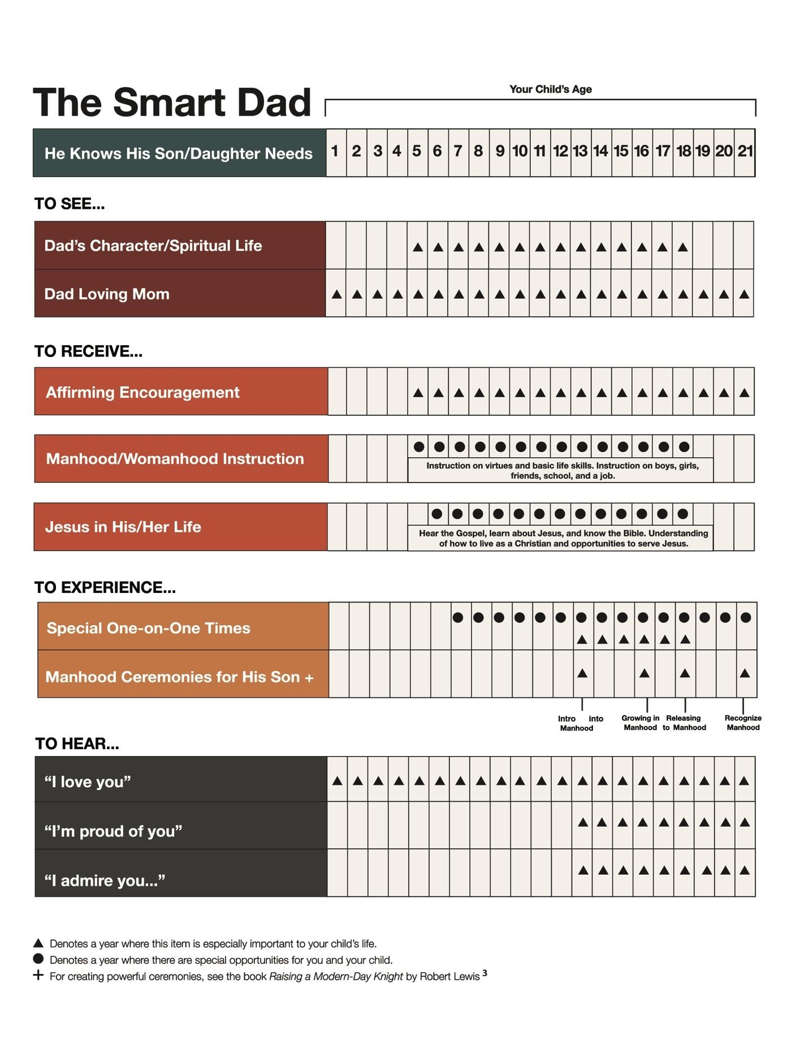

- He has committed himself to “dad plan” follow through.
- He knows “follow through” best happens when his plan includes other dads who are as committed as he is to raising their children well.
- He knows while a plan can’t guarantee a great outcome with his children, it will significantly increase that possibility.
- He regularly calls on God to help him be the best dad he can be. But when he fails his children (and he will), he asks God for grace to make up for his dad mistakes.

Healthy, well-adjusted sons and daughters don’t just happen. Smart dads, joined to God, make it happen!

- Helpful Advice to Fathers with Parenting Challenges

- If you’re a dad “disconnected” personally and emotionally from your son or daughter, know it’s never too late to close this gap no matter how old they are.
- Be courageous and request a meeting.
- Declare your love, express genuine sorrow over your separation, ask forgiveness where necessary, and explore ways to move forward.
- Reconnecting may require a series of meetings. Be open to that. Resist pressing for immediate reconciliation if your son or daughter is not ready.

- If you’re a single dad through divorce or death, or a dad with a blended family, don’t guess at your situation. Instead, seek outside help and wisdom to build a sound parenting strategy for going forward.
- Read helpful books and expand your horizons.
- Talk to successful single and blended-family dads. Let their experiences mentor you.
- Humble yourself and ask forgiveness where necessary, to repair damaged relationships with your kids.

- Helpful Advice to Sons with a Dad Wound
- Approach your dad wound responsibly.
- Find out what your dad’s story was with his dad. Often, knowing your dad’s story
helps with understanding how he wounded you.
- Admit the truth about your wound. Admit not just how dad hurt you, but also
what you lost as a son by him not being the dad you wanted him to be.
- Choose to forgive your dad.
- Choose to release your dad to God.

- Take the initiative with your dad. Don’t wait for him to come to you. Instead, courageously step forward and seek reconciliation with him while you can.

- Ask your dad to bless you. If you never heard him say to you, “I love you” or “I’m proud of you”; then go to him and courageously ask him for those blessings.

- Reclaim the relationship you missed with your dad by becoming a smart dad that blesses your children.

- If you know a man who never knew his dad, or a man who was rejected by his dad, consider asking some men he admires to join you in coming together and speaking a special blessing of affirmation and admiration over his life.

Your Table Discussion Questions
1. As a son, did you get what you needed from your dad growing up? If not, what did you miss? Is it possible to reclaim some of what you missed now?

2. Did you hear anything as a dad today that’s crying out to be addressed right now? What is it?

3. What in the sample “Dad Plan” presented today drew your attention? Why?

Your “BetterMan” Question
Before our next session, take a moment this week to reflect on your notes, and then answer the following question: What possible action step could I take from this session that could make me a better man? Write your answer down in the space below.

