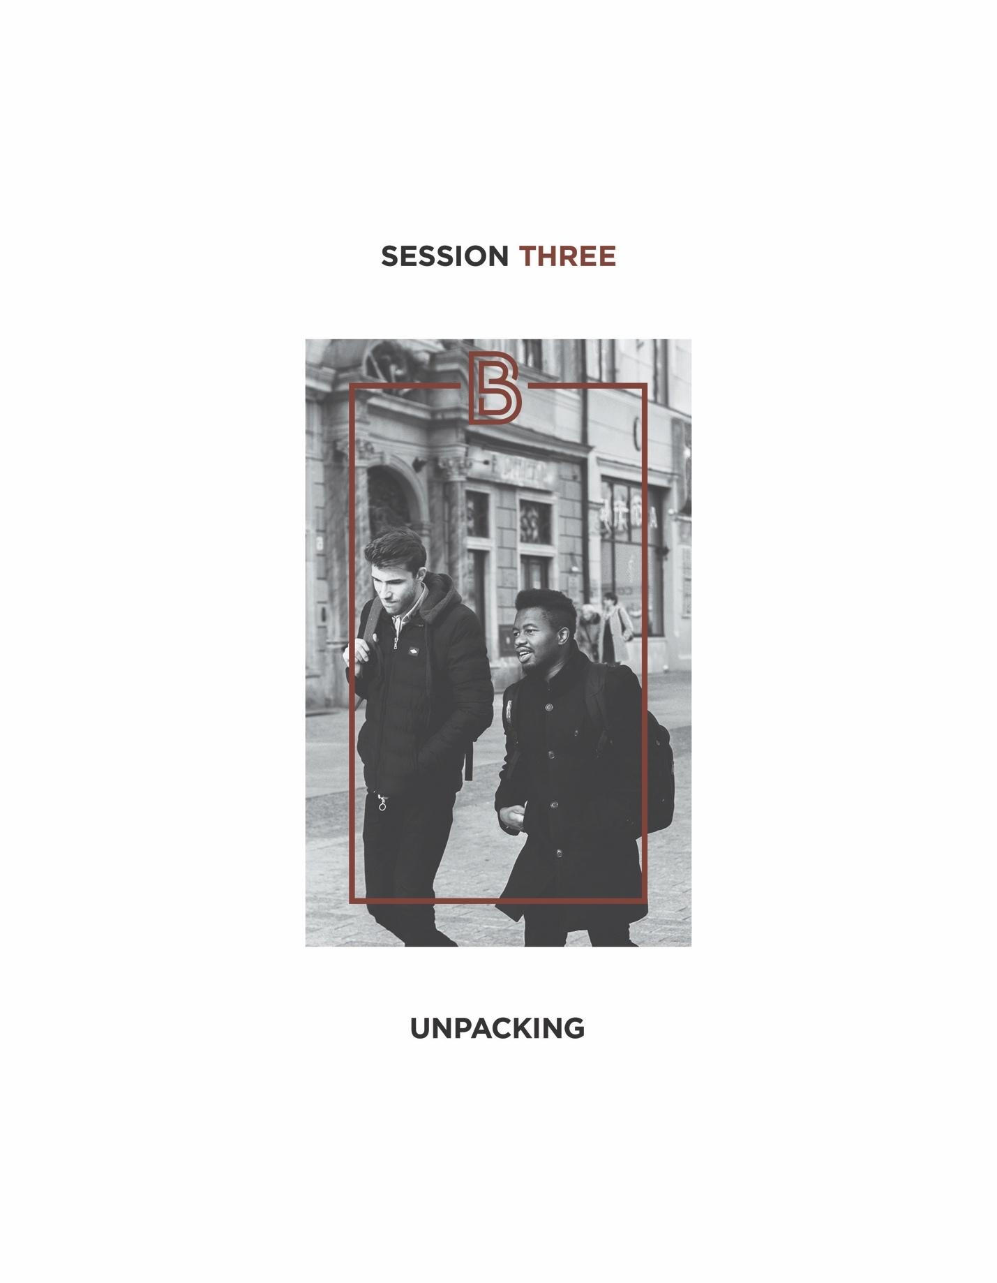

- An Outline of Our BetterMan Journey
- Understanding the present. (Session 1)
- Reviewing the times we live in as men.

- Envisioning the future. (Sessions 5-10)
- Defining life-giving manhood and offering specific, practical how to’s for living it out in the 21st century.

- Addressing the past. (Sessions 2-4)
- Addressing parts of our past can feel difficult and even overwhelming to some men.
- Addressing the past, however, is essential to building a better and more stable manhood. So don’t back down from this challenge!

- Two Action Steps for Addressing the Past
- Looking back: examining our past.
- Taking the time to tell our stories to each other. (Hopefully, you did that as a table group last week.)
- “Connecting the dots” between the past and the present.
- Making better sense of why we are the way we are.

- Unpacking: engaging our trouble spots.
- We must intentionally look for trouble spots from our past that are “alive” and active in our lives today.

“Trouble Spot” = any unresolved issue from the past where lack of closure adversely impacts and shapes the direction and dynamics of a man’s life now.

- We must courageously step into any trouble spot we find and seek to resolve it. In some cases, this will take the counsel and support of others.

- Common Trouble Spots that Undercut Our Manhood
- The dad wound.
- It’s impossible to overstate the impact of dad on a son’s life.
- Whatever your dad was like in your life, know this: when you grew up and left home, you didn’t leave your dad behind. He went with you as feelings and impressions you now carry within yourself.
- A lot of the hurt in men’s lives today comes from the absent dad.

“ Daddy gave me a name, then he walked away. I will never be safe, I will never be sane; I will always be weird inside, I will always be lame. Daddy gave me a name, then he walked away. Daddy gave me a name, then he walked away.¹ “Father of Mine” by Everclear

- Absent dads often bring on another trouble: “too much” mom. This can lead sons to either becoming overly dependent on women or overly dominant towards women later in life.

- The lack of a clear manhood vision.
- Manhood is not something you should “just know.”
- Manhood is not something that “just happens.”
- Real manhood is taught. It is a learned lifestyle. You see it modeled in men; you hear it talked about by men; and you receive skills from men to practice and apply it. If you’ve missed this instruction or parts of it, this becomes a trouble spot that will hold you back as a man.

- Unprocessed trauma.
- Life is turned upside down. It’s no longer safe, or fair, or just.
- “Why me? And where is God? I mean, really?”

Trauma breeds in a man fear, religious cynicism, dark feelings of insecurity, mistrust, anxiety, loneliness and more.

- Ongoing negative feelings from trauma usually need the help of others to resolve.

- Addictive habits.
- The big three: alcohol, drugs, pornography.
- This trouble often starts early in life and then stays late.

90% of adult addicts started using their addictive substances before age 18.

“ Like a city that is broken into and without walls is a man who has no control over his spirit.
Proverbs 25:28

- This trouble comes with the big lie, “I can handle it.” And then it grows into a ticking time bomb.

- No close friends.
- Isolation is at best unhealthy, and at worse deadly.
- Real manhood is a team sport.

“ Two are better than one... for if either of them falls, the one will lift up his companion. But woe to the man who falls when there is not another to lift him up. Ecclesiastes 4:9-10

- Every man needs at least one close friend

“ There is a friend who sticks closer than a brother. Proverbs 18:24

- Spiritually stuck.
- “Why would a loving God let this happen?”
- “These ‘believers’ betrayed me.”
- “I trusted God and it didn’t work.”
- “My parents are spiritual fakes.”
- “I struggle with doubts about God.”
- “My church was a terrible experience.”

- How To Address Your Trouble Spots
- Name it.
- Share it.

“ In an abundance of counselors there is victory.
Proverbs 11:14

“ He who walks with the wise, will be wise. Proverbs 13:20

“ Confess your sins to one another and pray for one another that you may be healed. James 5:16

If you’re open and transparent with others, you have the opportunity to be the best version of yourself.

- Engage it.
- Get a plan together that trusted family members and/or friends are willing to support you in.
- Take action. Courageously address your trouble spot as planned. Call on God to help you.

“ God is our refuge and strength. A very present help in time of trouble. Psalm 46:1

- Refuse to run from what’s hard.

“ If you can’t overcome hard, you’re never going to have any great victories in your life. 2
Coach Nick Saban

Your Table Discussion Questions
1. Which of the six trouble spots discussed today have you struggled with? Circle which trouble spot below that has had the biggest impact on your manhood. Then rate how much each trouble spot has affected you.
Trouble Spots
How Much Effect

O Little O Some O Significant
The Dad Wound

Lack of a Clear Manhood Vision
O Little O Some O Significant

Unprocessed Trauma
O Little O Some O Significant

Addictive Habits
O Little O Some O Significant

No Close Friends
O Little O Some O Significant

Spirituality Stuck
O Little O Some O Significant

2. If you’ve had progress in any of these six areas, share how this came about with your group. What was one “difference-maker” that helped you make progress in this trouble spot?

Your “BetterMan” Question
Before our next session, take a moment this week to reflect on your notes, and then answer the following question: What possible action step could I take from this session that could make me a better man? Write your answer down in the space below.

