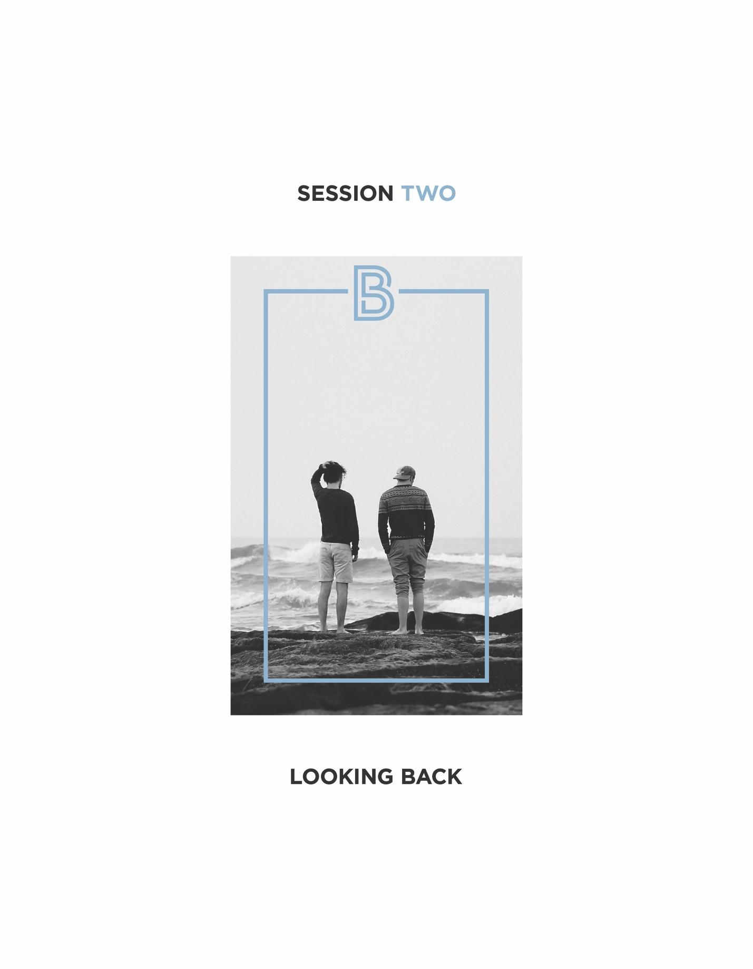

- Key Elements Shaping Our Manhood Today
- The challenges of our modern world:
- The loss of a common manhood vision... can “manhood be defined?
- “Weightless” manhood... a plague unleashed by absent dads and fatherless homes.
- A radically changing social landscape... merging sex roles, a decline in marriage.
- Lies men believe about themselves... “I should know what to do.”; “If I tell you the truth about myself, you will reject me.”
- The challenge of our past.
- Many men have never taken the time to “connect the dots” between their past and the present in a way that explains why they are the way they are, and why they feel the way they feel.

The Greek philosopher Socrates once said, “The unexamined life is not worth living.” It could also be said, unexamined manhood is hard to live with.

- When asked by a wife or a friend, “Why do you get so angry like that?”; “Why can’t you share your feelings with me?”; “What makes you act this way?”; “Why do you work all the time?”; “Why do you feel like that?” Many men have no answers, even for themselves.
- Minimizing or ignoring the impact of our past often undermines our present.

- Everybody Has a Story
- My Story
- Growing up…
- My family
- Noble moments
- Good moments
- Missed moments
- Hurtful moments
- Defining Moments

- Now as an adult…

Exploring our past helps explain “us” to “us”

- What’s your story?
- Do you really know it?
- Many of us have never shared our full story.

A “full story” goes beyond just facts about what happened in your past. It also includes how people and events from your past made you feel (loved, supported, encouraged, shamed, angry, lonely, abandoned, etc.), and how those feelings have helped to shape who you are now.

- Six “Looking Back” Truths
- The examined past is crucial to a better manhood. Without examination, the good from our past can go unappreciated, and the bad can unconsciously rule over us.
- When a boy fails to connect with his dad, demons of one kind or another often fill the void.

Behaviors born from an absent dad:
- Outbursts of anger/violence
- Workaholism
- Exploitation of women
- Acting out for approval
- Drugs/Alcohol/Pornography

- Many men have yet to process the “ unfinished business” from their pasts that still lives in them:
- Unfinished business includes unresolved tragedy, family breakup, personal conflict, abuse (personal, physical, or sexual), abandonment, betrayal, etc.
- Do you sense any unfinished business in your life?

- Until a man deals with the pain from his past, he can never be truly free.

- What negative messages do you often hear in your head?
- “Who” or “What” from the past do you need to come to grips with?

- You cannot effectively address the past or its impact in the present without the help of a few trusted friends. There is no such thing as a self-made man.

“ As iron sharpens iron, so one man sharpens another.
Proverbs 27:17

- For better or worse, we are all significantly shaped by where we come from. But though we are each a product of our past, no one has to be a prisoner of the past unless he chooses to be... either by denying it, ignoring it, or surrendering to it.

- The good news: You can break-free and find a better manhood.
- We’ll discuss “How” in our next session.

Your Table Discussion Questions
1. Share one positive asset you gained from your family growing up that is still making a difference in your life today.

2. If you could change one thing about your upbringing, what it would it be? Why?

3. Is there any pain or “unfinished business” from your past that you believe is still impacting your life now? Would you be willing to share what it is?

Your “BetterMan” Question
Before our next session, take a moment this week to reflect on your notes, and then answer the following question: What possible action step could I take from this session that could make me a better man? Write your answer down in the space below.

An Invitation...
This week we want to invite you to spend some extended time with your table members sharing with one another your life stories. Your table leader will help you in setting this time up. Here at the beginning of BetterMan, this is an opportunity to help you strengthen your table relationships and add depth and context to your future BetterMan discussions.

