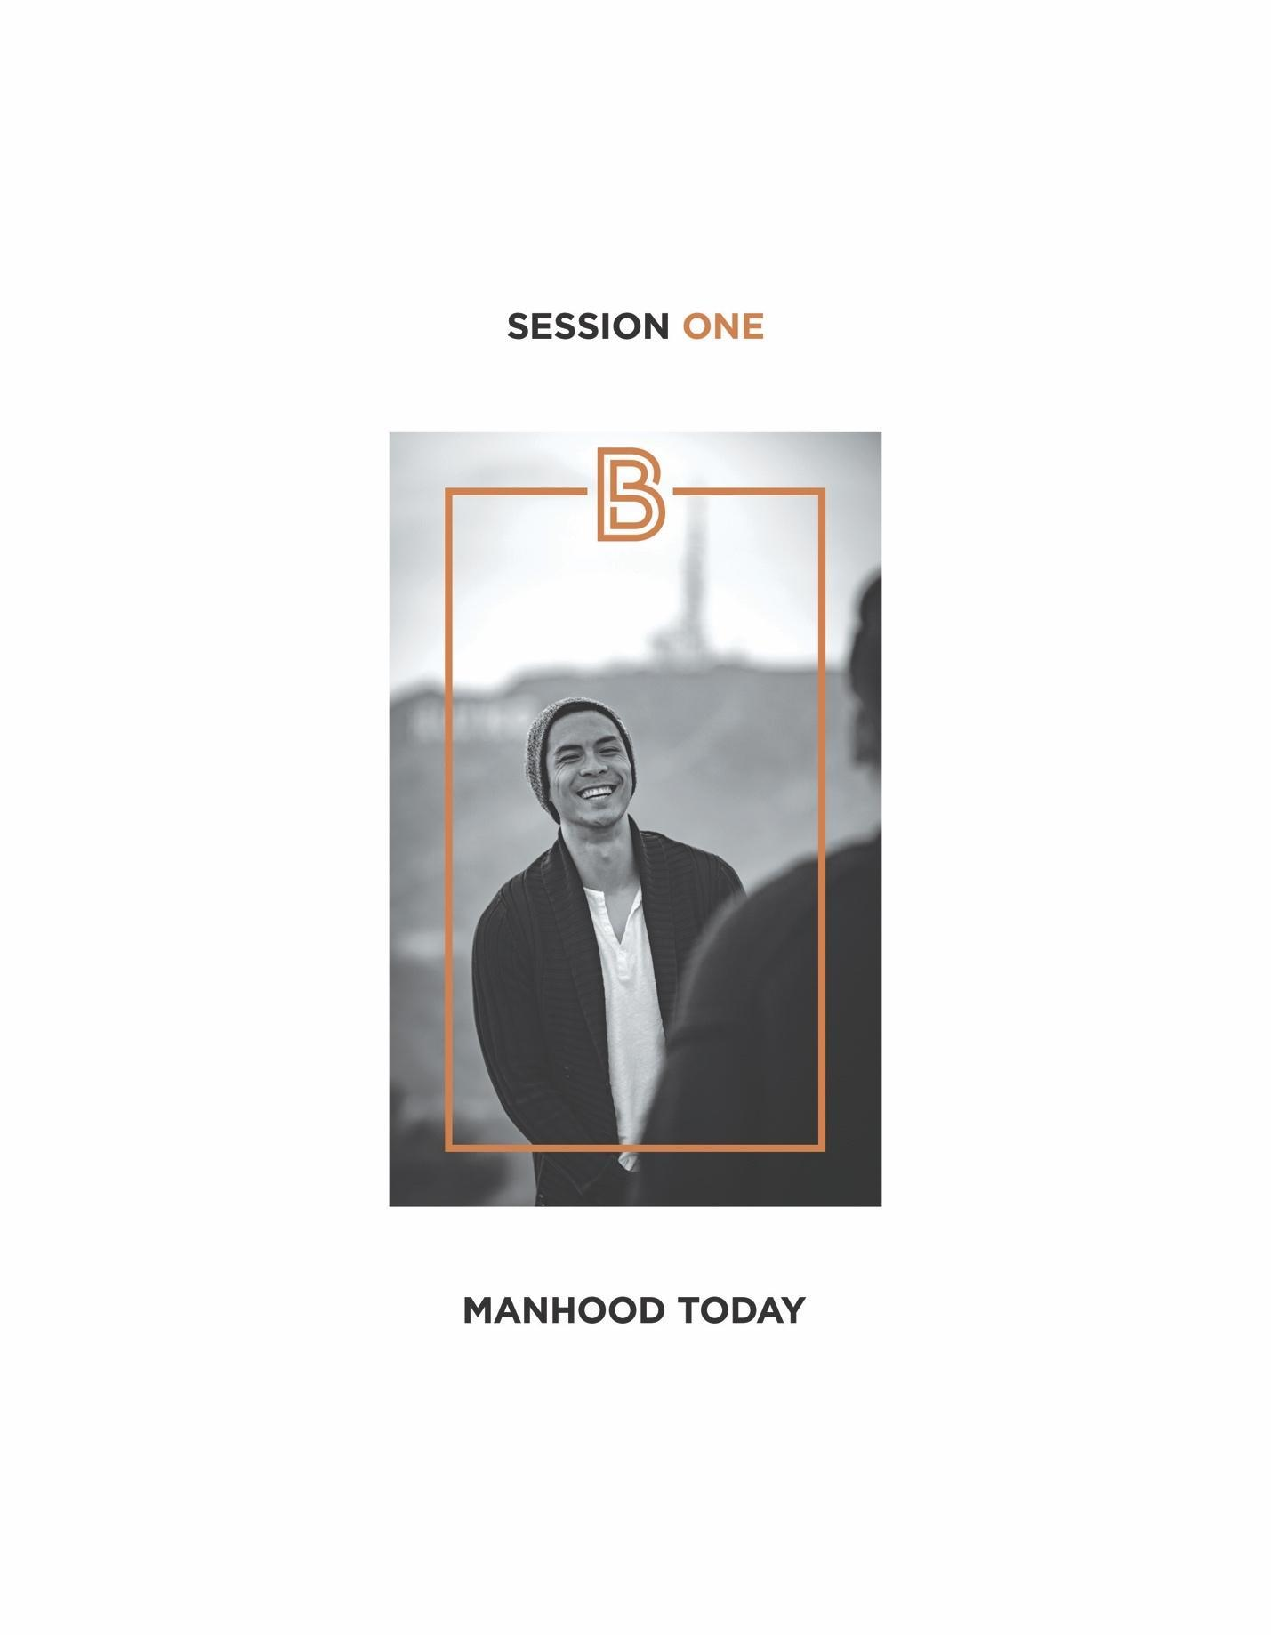

- Starting Line Perspectives
- As men, we have a lot in common.
- We all want to be better men.
- Some of us feel good about where we are right now, but also want to keep growing.
- Some of us have important manhood questions – “What do I need to know that I don’t?”; “What should be my top priorities?”; “How do I live without regrets?”
- Some of us need practical help – with our marriages, our kids, work, habits, friends, and spiritual life.
- Some of us are struggling and need a new direction.

- So How Are Men Doing Today?
- Some men have found a manhood that works.
And a manhood that truly works is life-giving.
- People are encouraged by it.
- Women and wives feel safe and valued around it.
- Families thrive with it.
- Sons are drawn to it.
- Daughters delight in it.
- The workplace and community benefit because of it.

“Life–giving” is the word the Bible uses to describe the manhood of Jesus. 1

- Some men live in a manhood “fog”.
- Times have changed and have left men conflicted and confused.
- So what does it mean to be a man today? In turning away from the answers of the past, we have yet to clearly define manhood for the present.

- Some men live in a manhood “struggle”.
- They settle for less in life, but they don’t know it’s less.
- They create problems…lots of them!
- They guess at their masculinity and hope it works.

After researching the cultures of history, world famous anthropologist, Margaret Mead, made this observation: “The chief responsibility of every society is to find healthy roles for its men.” Why? Because a culture that fails to offer its men a clear masculine blueprint for embracing good and noble pursuits, will see its men naturally dumb down to problematic behaviors. 2

- The Four Challenges Men Face Going Forward
- The loss of a common manhood vision.
- Without vision, we live in “no-man’s land.”
- Without vision, we are left to “make up” manhood for ourselves.

“ When there is no vision, the people run wild.
Proverbs 29:18

- The rise of a “weightless” manhood.
- It is created by the emotionally and/or physically absent dad. This loss of dad is significant on two important levels:
- Dad’s presence gives a son emotional stability: love and affirmation.
- Dad’s instruction gives a son directional stability: moral convictions and practical skills.

A stable loving home is the first and most important ingredient of human thriving.³

“ The glory of sons is their fathers.
Proverbs 17:6

- “Weightless” manhood unleashes a host of problems.
- It is an epidemic in America today.
In 1960, only 5% of boys in America were fatherless; today it’s 41%.⁴

- A radically changed, rapidly changing social landscape.
- The last 50+ years have been socially breathtaking:
- Men’s and women’s roles have increasingly merged.
- The definition of marriage was changed for the first time in over 4,000 years.
- Some 44% of millennials now consider marriage “obsolete”.
- Cohabitation has exploded. For the first time in American history, there are more unmarried adults than married.
- A majority of children (61%) born to mothers under 30, are born outside marriage.
- There are now multiple gender categories, not just male and female.
- Sexual standards have dramatically changed.
- Women now outnumber men in college by over 30% and earn more advanced degrees.
- Women now make up the majority of enrollees in law and medical schools.

“ At Colleges, Women are Leaving Men Behind in the dust.⁵ New York Times
- There are now 7 million working age men in the United States who don’t work.
- More women are managers in the workplace than men.
- Single women buy their own homes today at twice the rate of single men.
- Depression rates have increased tenfold among men since 1960.
- Women shoulder most of the responsibility for the health and vitality of the Christian faith in the United States.⁶

- Clearly women are excelling in today’s modern world while men have stalled.

- The lies men believe about themselves.

As men, we often make the mistake of processing out our lives alone.

- I should know what to do.
- I’m the only one who struggles with this.
- It’s too late to do anything about this.
- I can do this and no one will ever know.
- If I tell you the truth about myself, you will reject me.

- The Question
CAN WE DEFINE A MANHOOD THAT WILL WORK FOR US IN THE MODERN WORLD?

- Five Promises in Our BetterMan Journey
- You will increase your manhood understanding and make some significant personal discoveries.
- You will receive helpful insight and support from your table leaders.
- You will make new friends.
- You will have the opportunity to upgrade your manhood by using a weekly “BetterMan” Question.
- Without vision, we live in “no-man’s land.”
- Without vision, we are left to “make up” manhood for ourselves.

- You will receive a clear definition of manhood that will work for you in this modern world.
- This definition will be presented in Session 5.
- This definition will be spelled out with practical specifics in Sessions 6-10.

Your Table Discussion Questions
1. What brought you to BetterMan? What are you hoping for in being here?

2. Which one of “The lies men believe about themselves” did you circle in this session? Share why you were drawn to it.
3. Which of the 5 promises made in this session captured your attention the most? What is it about this promise that excites you?

